INTERIOR DESIGN GUIDELINES FOR SPACE PROJECTS

We are thrilled to welcome you into our world of creativity and design along with curating a new experience with you in designing your space.

Please note a few details to make the extensive design process smooth & systematic for all of us as mentioned below:

Post Preliminary Moodboard - Design Phase

a) We charge a nominal design fee for residential projects of up to
- 1000 sq.ft - Rs.1,50,000
- 1500 - 2000 sq.ft - Rs.2,50,000
- 2000 - 3000 sq.ft - Rs.3,50,000
- 3000 and above - Rs.4,50,000 (**design document with stages and deliverables mentioned below)
Or
- We charge a standard fee of Rs. 200/- per sq.ft.
Or
- 10% of the entire budget depending on the time consumed and requirements of a project.

- Commercial and hospitality - Rs. 350/- per sq.ft.
Or
Up to 2000 sq.ft - Rs.2,50,000 | 2000 sq.ft and above - Rs.3,50,000

b) Payment schedule - Advance payment to be the mode of business, Designer to commence a particular stage once fees has been cleared for the same.

For turnkey solutions - a retainer fee will be set in accordance with the client depending upon the mutually agreed number of site visits and scope of work.

c) Our scope of work involves Conceptualisation, Design Development, Material sourcing. We cater to Furniture,Furnishing, Decor, lighting. The final scope will be mutually agreed upon based on project details.
d) We will be involved in all designs pertaining to the needs of the client and options will be shared for the same. Design will be changed and redone if client expectations are not met within the first phase of design.

e) Once the final concept and items are approved we go into the next stage with BOQ/ material calculations , quotations and project timelines based on the client approvals. Once the production starts we will not be in a position to cater to any change in design or concept.

f) The drawing made will be shared with the appointed contractors/ vendors for the purpose of execution . We will not take up any civil, plumbing or electrical work unless approved by Owner/ builder / architect.

g) No internal drawings (hardcopy or softcopy) can be shared with clients without full design fee payment. The same will be viewed over zoom calls or in person only for discussion purposes.

h) Site visits and meetings will be held according to requirements. All design meetings till the stage of material finalisation will be held over Google Meet / Zoom, for work outside Goa.

i) All material delivered onsite to be signed by the client or his representative.

j) Communication with our vendors will not be allowed as it creates mishaps and confusion in the future.

k) We avoid dealing with white appliances, and anything related to it. We shall not be held responsible for any damages caused to any appliances in the process.

l) Client inputs are most valuable to us at all stages and as a team we are committed to make this a happy and successful experience for each one of us. All notes to be put on mail or the project whats app group (by the designer or the client). Anything verbally instructed/ selected will not be accounted for.

The following is our design process in brief:

- Advance payment amounting to 50% of the design fee is required to start the design process.
- Whatsapp project group and a mail trail will be created for communication related to the project. Sincere request to avoid multiple mail trails + one on one whats app messages with designers to avoid any miscommunication and irregularities.
- A preliminary look & feel moodboard will be sent to understand the direction of the design language our client is inclined towards.
- Once we understand our client’s design language, an intensive moodboard will be made which would mainly include the elements and reference images as options for furniture. 3D models will be made as per designer’s requirements. (without renders)
- We will then move on to lighting options, electrical drawings , false ceiling designs and wall treatment.
- Post finalising of all the above , material finishes will be discussed and finalised.
- A final design document will be prepared with all final designs which will be signed by the client
- Before execution, a final presentation will be prepared before moving onto execution which will be signed by the designer and the client stating the designs, finishes and dimensions.

Please Note:-

1. No Changes Will Be Entertained Post Design Document Finalisation.

2. In progress images will not be shared to clients - only carcass images before the second instalment will be shared.

3. Scope of work will not be reduced post finalisation of quotation-any changes in scope of work will alter timelines and payment schedule.

4. Any additional scope of work will be considered as a fresh project with separate timelines.100 % payment will be required for any additional scope of work during the execution of the first phase.

DESIGN PROCESS - (6 WEEKS MINIMUM)

- Any changes in market rates during the project will be charged accordingly-since the material market is a highly volatile market any quotations shared will be valid for 10 days.

- Materials’ non-availability might result in changes during the execution stage which will be communicated by the designer to the clients.

- After receiving notice of furniture completion delivery must be taken within 7 days.

PHASE 1 - (1 week) - MOOD BOARD - look and feel + Material board + Reference images + Space lay-outing

PHASE 2 - (2 weeks) - Base Material selection (carcass + finish material) + Changes + Render (1st week) + 2D drawings (2nd week)

*Design fee - second instalment

PHASE 3 - (1 week ) - Submission of 3D views + Material Selections (fabric + wall paint + finishes + polish colour etc)

PHASE 4 - ( 1 week) - BOQ + Final Design Document

DESIGN DOCUMENT WILL INCLUDE:

- Floor plan
- Floor dimensional plan
- Furniture layout with all dimensions
- False ceiling plan - RCP
- Electrical plan - RCP
- Switchboard legend
- Electrical looping plan
- Light fixtures list
- Furniture Drawings + Specs
- Furnishing + Mattress spec
- Wall treatment specs
- Civil changes - drawings
- Tile/ Flooring Specifications
- *Decor + Statement fixtures + Bathroom Sanitary fixtures can be selected post as per actuals Standard Material Specification
- Sourcing Lists

————————————————————————————————————————

Working hours | Monday - Friday 10:30am - 7:30pm - Saturday and Sunday of every month will be an off. All national + religious holidays will be marked while giving the execution timeline. Any communication post 7:30pm will be taken up the next working day.

We will serve to the best of our capabilities and hope to create an enjoyable designing journey with you!

Thankyou for choosing us!

CLIENT:

DATE:

CLIENT’S SIGN:
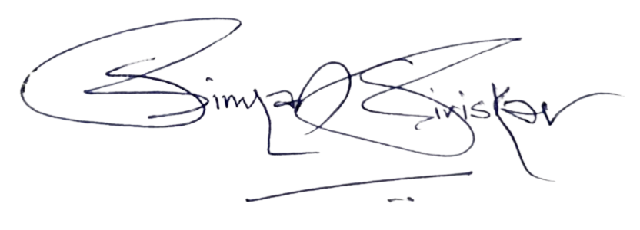

DESIGNER’S SIGN:

